Scale Rate Models

Contents:
- Historical Data
- Current Coupon Model
- Mortgage Spread Model
- Mortgage Rate Model

Historical Data

Historical data is pulled into Scale via a google protobuf file. These files are generated daily via a C# program which queries our Cello time series tables.

We generate 3 daily and monthly series for consumption by Scale:
- Historical 30Yr Primary Mortgage Market Survey Rate
  - The PMMS rates are published every Thursday and assumed to be backward looking. For example, the rates published on 9/18 (Thursday) should be the average rate from 9/11 (last Thursday) to 9/17 (Wednesday). Therefore, the rate published on 9/18, say 4.23%, is stored for 9/11 - 9/17.
  - Apply the Fee&Points adjustment on the mortgage rates.
    - RawRate - (1 - Fee&Points) / 4.
  - For example, the rate published on 9/18 is 4.23% with Fee&Points 0.5, then the mortgage rate used should be 4.23 - (1 - 0.5) / 4 = 4.105%

- Historical 30Yr Current Coupon Rate
  - The daily current coupon rate is calculated in the following fashion:
Suppose we want to calculate Fannie Mae current coupon. Suppose on 10/29/2014, we have the near-par, front-month TBA prices; FNMA 2.5-TBA-NOV: 96.453125, and FNMA 3-TBA-NOV: 100.023438, both settling on 11/13/2014. We also have corresponding back-month TBA prices; FNMA 2.5-TBA-DEC: 96.21875, and FNMA 3-TBA-DEC: 99.734375, both settling on 12/11/2014. The goal is to compute the price for a synthetic at-par TBA settling in 30 days with 25 days delay (specific to FNMAs), and then to use the price to derive the current coupon rate.
  - 30 Day Forward Prices:
There are 15 calendar days between 10/29/2014 and 11/13/2014, 43 between 10/29/2014 and 12/11/2014. For FNMA 2.5s, the forward price (30 days) is (30-15)/(43-15)*( 96.21875-96.453125)+96.453125 = 96.32756696, and for FNMA 3s, is (30-15)/(43-15)*( 99.734375-96.21875)+ 96.21875 = 99.86858282.
  - Payment Delay Adjustment
With 25-day delay adjustment, the prices are: 96.32756696 + (25-1)/360*2.5 = 96.49423363 for FNMA 2.5s, and 99.86858282 + (25-1)/360*2.5 = 100.0685828 for FNMA 3s.
  - Monthly Par Rate
The implied yield from the prices is (100-96.49423363)/(100.0685828-96.49423363)*(3.0-2.5)+2.5 = 2.9904.
  - Yield Conversion
To convert the mortgage yield (monthly compounded) to bond equivalent yield (semi-annually compounded), we have ((1+2.9904/1200)^6-1)*200 = 3.009
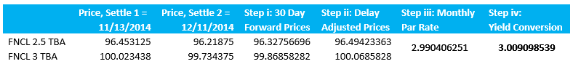

- Historical Swap 10Yr
  - Daily data are obtained from YieldBook

Data Massaging
- Fill in mortgage rates for current week
  - As mentioned above, we only have mortgage rates data for the previous week. For example, if the pricing date is 9/23/2014, the latest rate published is 9/18, which is used for 9/11 - 9/17, and we do not have "historical" rate for 9/18 - 9/23. We need to do the following:
    - For the week 9/11 - 9/17, the spread = AvgMortgageRate[9/11 - 9/17] - AvgCurrentCoupon[9/11 - 9/17].
  - Do the same for the previous weeks and use the average of previous 2 weeks, to avoid bumps. The "2" should be a parameter adjusted by the user.
  - For the current week, 9/18 - 9/23, we have historical current coupon rates, so we use these along with the computed spread to get mortgage rates.

Current Coupon Model
v1.0

Current coupon projections are based on 10 Yr Swap Rates and Current Coupon Spreads.

CC Spread = Current Coupon – Swap 10Yr

The Current Coupon Spread is calculated as the average from the last 2 weeks of data.
The Current Coupon Spread is assumed to be constant throughout the projection.

Mortgage Spread Model
v1.0

Mortgage rate projections are based on Current Coupon Rates and Mortgage Spreads.

Mortgage Spread = Mortgage Rate – Current Coupon

The Constant Mortgage Spread is calculated as the average from the last 2 weeks of data.
The Projected Mortgage Spread is calculated as an exponential decaying function of time.
The long term spread is 1%

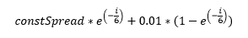

Mortgage Rate Model
v1.0

Mortgage rate projections are based on 10 Yr Swap Rates, Current Coupon Model and Mortgage Spread Model.
Raw Mortgage Rate = Swap 10Yr + CC Spread + Mortgage Spread
Projected Mortgage Rate = 3 Point Average of Raw Mortgage Rates

Given a vector of 10 Yr Swap rates, a current coupon spread and a mortgage spread we can calculate the raw mortgage rate.
The mortgage rates used for our projections are a 3 point average using the current month, previous month and next month data.

Computing 3 Point Monthly Average
Assume we have projected mortgage rates every month (9/24, 10/24, 11/24, ....) for 30 years. We need to do the following to interpolate them to get average monthly rates:

- For any month but current month (See Figure 1), the formula is simple. Suppose the latest mortgage rate (MR_{i}) is the jth calender day of that month, and there are x calendar days in that month. Also suppose there are y calendar days between this available date and previous date (MR_{i-1}), and z calendar days between the latest date and the next date (MR_{i+1}). The formula is:
AvgRatei = [(MRy + MRi)/2 * j + (MRz + MRi)/2 * (x - j + 1) - MRi] / x
where MRy = (MRi - MRi-1)*(y - j + 1) / y + MRi-1
and MRz = (MRi+1 - MRi)*(x - j) / z + MRi
- For the current month average rate, the calculation is more complicated because we need to use the daily rates for the dates before the pricing date in the same month. The rates calculated from 1 will be used and historical daily rates as well. Also note that here we should use business days instead to avoid errors.
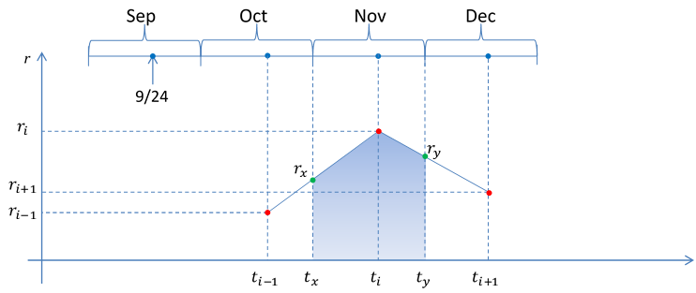
Example Calculations
Forward Month Calculation
currDate | 11/9/2015
prevDate | 10/9/2015
nextDate | 12/9/2015
prevMonthDays | 31 | 31
currentMonthDays | 30 | 30
mNumDaysSinceMonthStart | 9 | 9
currRate | 0.037121
prevRate | 0.036968
nextRate | 0.037251
mortgageRateY | 0.037082 | 0.037082
mortgageRateZ | 0.037212 | 0.037212
mortgageRate | 0.037149 | 0.037148
Current Month Calculation
currDate | 10/9/2015
nextDate | 11/9/2015
avgRateCurr | 0.03676
numBusinessDaysToDate | 6
numBusinessDaysInMonth | 21
currRate | 0.036968
nextRate | 0.037121
mortgageRateZ | 0.037078 | 0.037077
mortgageRate | 0.036950 | 0.036950

